Milestone No. 2
ERD Design & Normalization
Project: PC Build Recommendation System (Web-Based)
Group Members: Umer Daraz Habib and Kashif

Version History
Milestone | Version | Remarks
ERD Schema | 1.0 | Approved
ERD Schema (Normalized) | 1.1 | Changes Accommodated
Normalization Document | 2.0 | 1NF / 2NF / 3NF applied to all tables

Step 1 — Apply Normalization
This section reviews every table in the schema and applies the normalization process in sequence: First Normal Form (1NF), then Second Normal Form (2NF), then Third Normal Form (3NF). For each normal form, we explain whether an issue was found, what change was made (if any), and why. Where the table already satisfies a normal form, a justification is provided explaining why no change was required.

1. User
Description:
Stores basic information about system users including login credentials and role (admin or regular user). Each user is uniquely identified by user_id.
First Normal Form (1NF):
No issue found. All attributes contain atomic values — there are no lists, arrays, or repeating groups within any column. For example, full_name stores a single name, and role stores a single value (either admin or user). Each row represents exactly one user, and each user is uniquely identified by the primary key user_id.
No change was required because the table already satisfies the conditions of 1NF.
Second Normal Form (2NF):
No issue found. The table has a single-column primary key (user_id), so partial dependency on a composite key is not possible by definition. All non-key attributes (full_name, email, password, role) depend fully on user_id.
No change was required because the table already satisfies the conditions of 2NF.
Third Normal Form (3NF):
No issue found. None of the non-key attributes depend on another non-key attribute. For example, role does not depend on email, and password does not depend on full_name — each is determined directly by user_id.
No transitive dependency exists, so no change was required.

Attribute | Datatype | Constraints
user_id | INT | Primary Key, NOT NULL
full_name | VARCHAR(50) | NOT NULL
email | VARCHAR(45) | NOT NULL, UNIQUE
password | VARCHAR(255) | NOT NULL
role | VARCHAR(20) | NOT NULL

2. Build_Request
Description:
Stores user requests for PC builds, including the budget provided by the user and the intended purpose (e.g., gaming, editing, programming, general use). Each request is linked to the user who submitted it.
First Normal Form (1NF):
No issue found. All attributes are atomic — budget is a single decimal value, purpose holds a single category string, and request_date stores one date. There are no repeating groups or multi-valued attributes. Each request is uniquely identified by request_id.
No change was required.
Second Normal Form (2NF):
No issue found. The primary key request_id is a single column, so partial dependency cannot occur. All other attributes (budget, purpose, request_date, user_id) depend fully on request_id.
No change was required.
Third Normal Form (3NF):
No issue found. No non-key attribute depends on another non-key attribute. For example, budget does not depend on purpose, and purpose does not depend on user_id. The foreign key user_id only references the User table; it does not introduce a transitive dependency on any user attribute within this table.
No change was required.

Attribute | Datatype | Constraints
request_id | INT | Primary Key, NOT NULL
budget | DECIMAL(10,2) | NOT NULL
purpose | VARCHAR(45) | NOT NULL
request_date | DATE | NOT NULL
user_id | INT | FOREIGN KEY → User(user_id)

3. Component
Description:
Stores all available PC hardware components such as CPU, GPU, RAM, motherboard, and storage, along with their pricing and specification details.
First Normal Form (1NF):
No issue found. All attributes are atomic. Each row represents exactly one component, and fields like brand, price, and specifications each hold a single value. There are no repeating groups or comma-separated lists inside any column.
No change was required.
Second Normal Form (2NF):
No issue found. The primary key component_id is a single column, so no partial dependency is possible. All non-key attributes (component_name, component_type, brand, price, specifications, compatibility_info) depend fully on component_id.
No change was required.
Third Normal Form (3NF):
No issue found. No non-key attribute determines another non-key attribute. For example, brand does not determine price (two products from the same brand can have different prices), and component_type does not determine specifications. Every non-key attribute depends directly on the primary key component_id.
No transitive dependency exists, so no change was required.

Attribute | Datatype | Constraints
component_id | INT | Primary Key, NOT NULL
component_name | VARCHAR(100) | NOT NULL
component_type | VARCHAR(45) | NOT NULL
brand | VARCHAR(30) | NOT NULL
price | DECIMAL(10,2) | NOT NULL
specifications | TEXT | —
compatibility_info | TEXT | —

4. Recommended_Build
Description:
Stores system-generated PC build recommendations based on user requests. Each recommended build is generated in response to one build request and has a total cost.
First Normal Form (1NF):
Issue found. In the original schema, the Recommended_Build table included component_id as a column. Since a single recommended build typically contains multiple components (CPU, GPU, RAM, motherboard, storage, etc.), placing component_id directly inside Recommended_Build would have required either listing multiple component IDs in one field (violating atomicity) or duplicating the entire build row once per component (a repeating group).
Change made: Removed component_id from Recommended_Build and moved the build-to-component relationship into a separate junction table called Build_Component.
Why: Removing component_id eliminates the repeating group and ensures every column holds a single, atomic value. The many-to-many relationship between Recommended_Build and Component is now represented correctly through the junction table.
Second Normal Form (2NF):
No issue found after the 1NF correction. The primary key build_id is a single column, so partial dependency is not possible. All remaining attributes (total_cost, recommendation_date, request_id) depend fully on build_id.
No further change was required.
Third Normal Form (3NF):
No issue found. No non-key attribute determines another non-key attribute. total_cost does not depend on recommendation_date, and recommendation_date does not depend on request_id. Every non-key attribute depends directly on build_id.
No transitive dependency exists, so no further change was required.

Attribute | Datatype | Constraints
build_id | INT | Primary Key, NOT NULL
total_cost | DECIMAL(10,2) | NOT NULL
recommendation_date | DATE | NOT NULL
request_id | INT | FOREIGN KEY → Build_Request(request_id)

5. Build_Component
Description:
Junction (associative) table that resolves the many-to-many relationship between Recommended_Build and Component. Each row records one component included in one recommended build, along with the quantity of that component.
First Normal Form (1NF):
No issue found. Each row stores exactly one component for one build, with a single quantity value. All attributes are atomic and there are no repeating groups. Each row is uniquely identified by build_component_id.
No change was required.
Second Normal Form (2NF):
No issue found. The table uses a single surrogate primary key build_component_id, so partial dependency on a composite key is not possible. All non-key attributes (quantity, build_id, component_id) depend fully on build_component_id.
Note: An alternative valid design would use a composite primary key of (build_id, component_id). The current design uses a surrogate key for simplicity and to allow the same component to appear in a single build with a different role if ever needed.
No change was required.
Third Normal Form (3NF):
No issue found. No non-key attribute determines another non-key attribute. quantity does not depend on build_id or component_id alone — it depends on the combination, which is fully represented by the primary key. The foreign keys build_id and component_id only reference their parent tables and introduce no transitive dependencies inside Build_Component.
No change was required.

Attribute | Datatype | Constraints
build_component_id | INT | Primary Key, NOT NULL
quantity | INT | NOT NULL
build_id | INT | FOREIGN KEY → Recommended_Build(build_id)
component_id | INT | FOREIGN KEY → Component(component_id)

Step 2 — Remove Duplicates
Every table was reviewed for redundant columns, repeated data, and overlapping attributes. The findings and actions taken are documented below.

Duplicates and Redundancies Identified
- Recommended_Build originally contained component_id, which caused the entire build row to repeat once for every component included in that build. This created redundant total_cost, recommendation_date, and request_id values across many rows for the same logical build.
- No other table contained redundant columns. User, Build_Request, and Component each store a distinct concept with no overlapping attributes.

Actions Taken
- Removed component_id from Recommended_Build.
- Introduced Build_Component as a junction table containing build_id and component_id as foreign keys, plus quantity to track how many units of a component are included in a build.
- Verified that no attribute is stored in more than one table. Foreign keys (user_id, request_id, build_id, component_id) are stored only in their parent tables; child tables reference them by key, not by copying the data.

Result
After these changes the schema contains no repeating groups, no duplicated data across rows, and no overlapping attributes between tables. Every fact is stored in exactly one place.

Step 3 — Updated ERD
The ER Diagram has been updated to reflect all changes made during normalization. The final ERD shows five entities — User, Build_Request, Component, Recommended_Build, and Build_Component — with all primary keys, foreign keys, relationships, and cardinalities accurately represented.

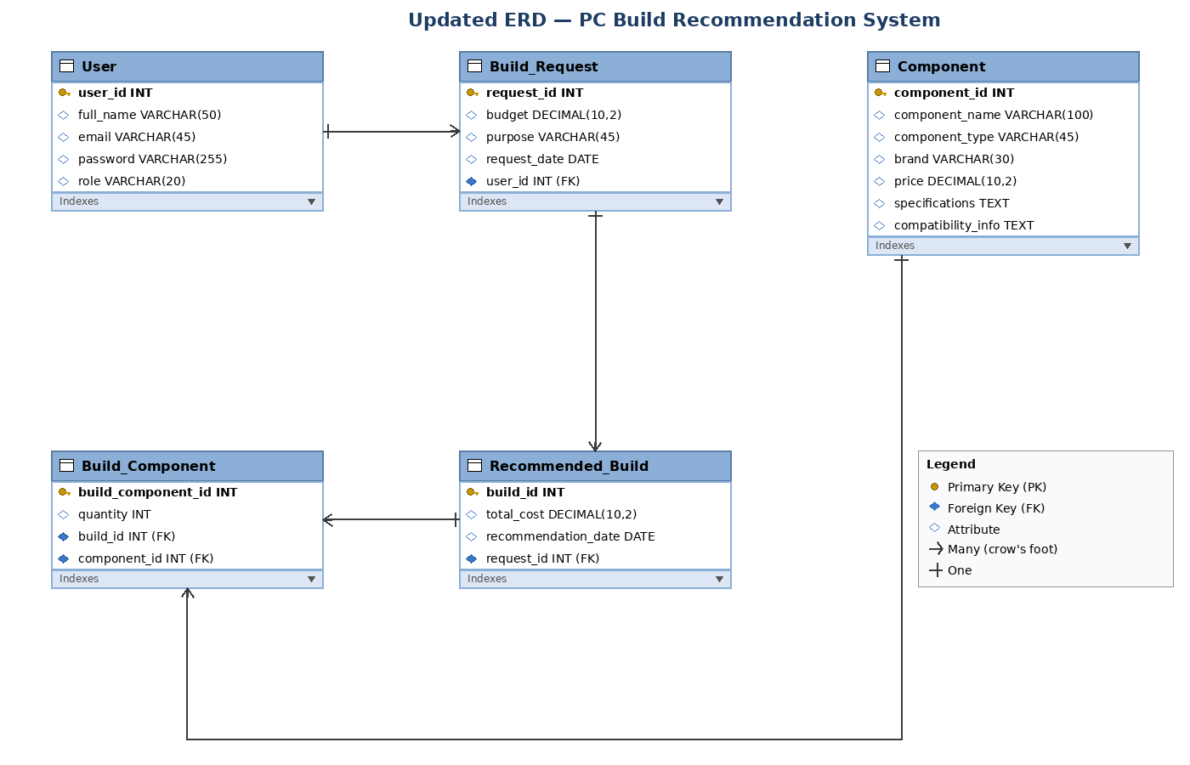
Figure 1 — Updated ERD for the PC Build Recommendation System (Version 1.1)

Key Changes Reflected in the Updated ERD
- component_id has been removed from Recommended_Build.
- Build_Component now includes component_id as a foreign key referencing Component(component_id), in addition to build_id.
- A relationship line has been drawn between Build_Component and Component to represent the One-to-Many relationship (one component can appear in many build entries).
- All cardinality markers (one and many) are shown on every relationship.

Relationship Summary
Relationship | Type | Description
User → Build_Request | One-to-Many | One user can submit many build requests.
Build_Request → Recommended_Build | One-to-Many | One build request can generate multiple recommended builds.
Recommended_Build → Build_Component | One-to-Many | One recommended build can include many component entries.
Component → Build_Component | One-to-Many | One component can appear in many build entries across different builds.
Recommended_Build ↔ Component (via Build_Component) | Many-to-Many | Resolved through the Build_Component junction table — a build can contain many components, and a component can be used in many builds.

Conclusion
All five tables in the PC Build Recommendation System schema now satisfy First, Second, and Third Normal Form. Redundancies have been removed, the many-to-many relationship between builds and components is resolved through a proper junction table, and the ERD has been updated to reflect the final normalized design.

